WEEK 3
SESSION: Date and Time Handling Concepts
TASK11A: Java Date and Time
PROGRAM:
public class Solution {
public static void main(String[] args) throws IOException {
BufferedReader bufferedReader =
new BufferedReader(new InputStreamReader(System.in));
BufferedWriter bufferedWriter =
new BufferedWriter(new FileWriter(System.getenv("OUTPUT_PATH")));
String[] firstMultipleInput =
bufferedReader.readLine()
.replaceAll("\\s+$", "")
.split(" ");
int month = Integer.parseInt(firstMultipleInput[0]);
int day = Integer.parseInt(firstMultipleInput[1]);
int year = Integer.parseInt(firstMultipleInput[2]);
String res = Result.findDay(month, day, year);
bufferedWriter.write(res);
bufferedWriter.newLine();
bufferedReader.close();
bufferedWriter.close();
}
}
Output:
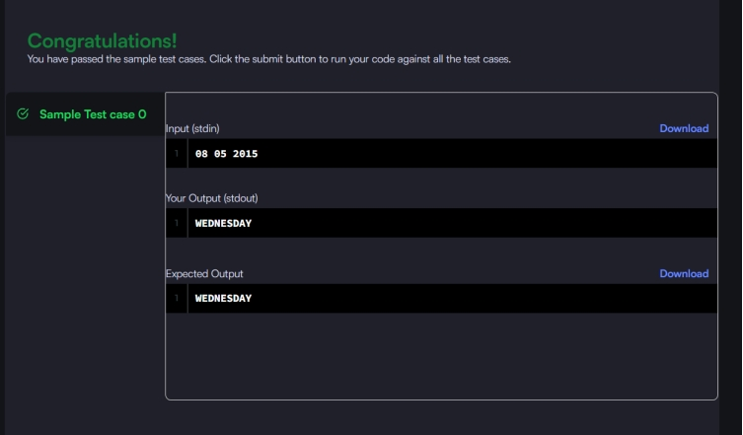

TASK11B: Number of Days Between Two Dates
PROGRAM:
import java.time.LocalDate;
import java.time.temporal.ChronoUnit;
class Solution {
public int daysBetweenDates(String date1, String date2) {
LocalDate d1 = LocalDate.parse(date1);
LocalDate d2 = LocalDate.parse(date2);
return (int) Math.abs(ChronoUnit.DAYS.between(d1, d2));
}
}
OUTPUT:
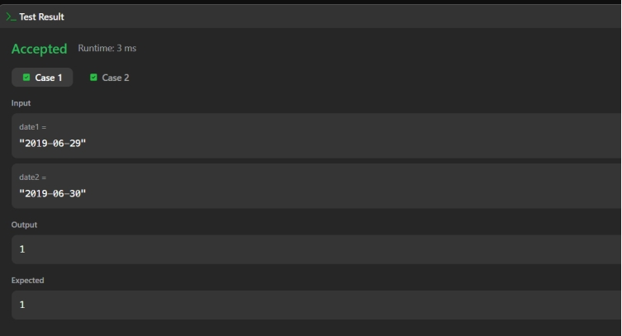
TASK12: Date and Time Handling Concepts
12A: . Day of the Year
PROGRAM:
import java.time.LocalDate;
import java.time.format.DateTimeFormatter;
class Solution {
public int dayOfYear(String date) {
DateTimeFormatter formatter =
DateTimeFormatter.ofPattern("yyyy-MM-dd");
LocalDate ld = LocalDate.parse(date, formatter);
return ld.getDayOfYear();
}
}
OUTPUT:
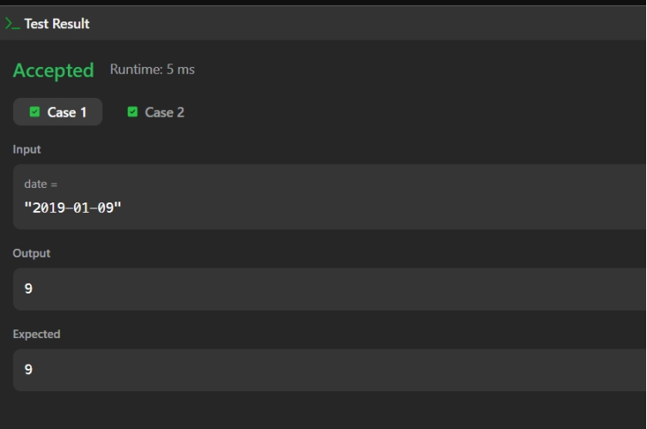
12B: Day of the Week
PROGRAM:
import java.time.LocalDate;
import java.time.format.TextStyle;
import java.util.Locale;
class Solution {
public String dayOfTheWeek(int day, int month, int year)
LocalDate ld = LocalDate.of(year, month, day);
return ld.getDayOfWeek().getDisplayName(TextStyle.FULL, Locale.ENGLISH):
}
}
OUTPUT:
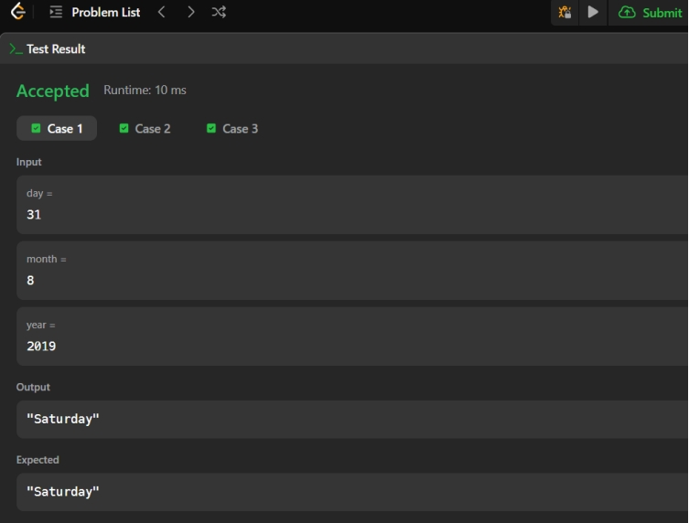
TASK13: Collection Processing & Transformation Operations
13A: Java Priority Queue
PROGRAM:
class Priorities {
public List<Student> getStudents(List<String> events) {
// Highest priority student comes first
PriorityQueue<Student> pq = new PriorityQueue<>(
new Comparator<Student>() {
@Override
public int compare(Student s1, Student s2) {
// Higher CGPA first
if (s1.getCGPA() != s2.getCGPA()) {
return Double.compare(s2.getCGPA(), s1.getCGPA());
}
// Same CGPA: name in ascending alphabetical order
int nameCompare = s1.getName().compareTo(s2.getName());
if (nameCompare != 0) {
return nameCompare;
}
// Same CGPA and name: lower ID first
return Integer.compare(s1.getID(), s2.getID());
}
}
);
for (String event : events) {
String[] parts = event.split(" ");
if (parts[0].equals("ENTER")) {
String name = parts[1];
double cgpa = Double.parseDouble(parts[2]);
int id = Integer.parseInt(parts[3]);
pq.add(new Student(id, name, cgpa));
} else if (parts[0].equals("SERVED")) {
if (!pq.isEmpty()) {
pq.poll();
}
}
}
// Return remaining students in priority order
List<Student> result = new ArrayList<>();
while (!pq.isEmpty()) {
result.add(pq.poll());
}
return result;
}
}
OUTPUT:
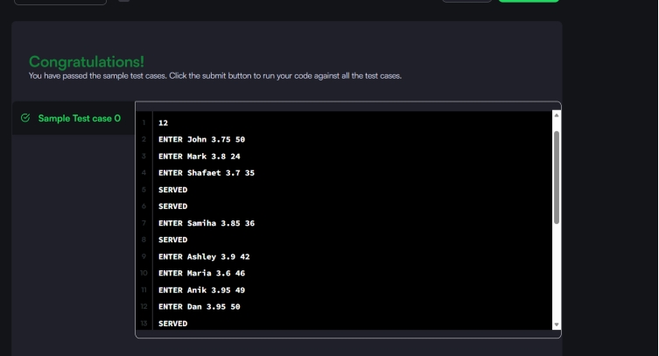

TASK13B: Java Arraylist
PROGRAM:
public class Solution {
public static void main(String[] args) {
Scanner sc = new Scanner(System.in);
// Number of lines
int n = sc.nextInt();
// ArrayList containing an ArrayList for each line
ArrayList<ArrayList<Integer>> lines = new ArrayList<>();
// Read all lines
for (int i = 0; i < n; i++) {
// Number of integers in this line
int d = sc.nextInt();
ArrayList<Integer> currentLine = new ArrayList<>();
for (int j = 0; j < d; j++) {
currentLine.add(sc.nextInt());
}
lines.add(currentLine);
}
// Number of queries
int q = sc.nextInt();
// Process queries
for (int i = 0; i < q; i++) {
int x = sc.nextInt();
int y = sc.nextInt();
// Convert 1-based positions to 0-based indexes
if (x >= 1 && x <= n &&
y >= 1 && y <= lines.get(x - 1).size()) {
System.out.println(lines.get(x - 1).get(y - 1));
} else {
System.out.println("ERROR!");
}
}
sc.close();
}
}
OUTPUT:
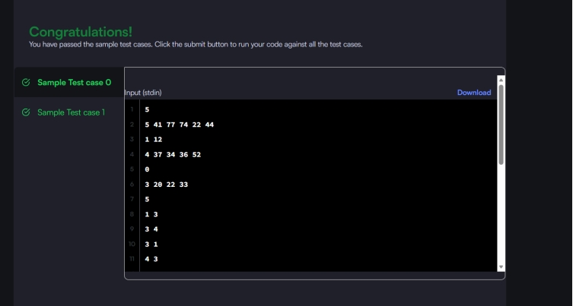

TASK14: Custom Comparators
14A: Largest Number
PROGRAM:
import java.util.*;
class Solution {
public String largestNumber(int[] nums) {
String[] arr = new String[nums.length];
for (int i = 0; i < nums.length; i++) {
arr[i] = String.valueOf(nums[i]);
}

Arrays.sort(arr, new Comparator<String>() {
@Override
public int compare(String a, String b) {
String ab = a + b;
String ba = b + a;
return ba.compareTo(ab);
}
});
if (arr[0].equals("0")) {
return "0";
}
StringBuilder result = new StringBuilder();
for (String s : arr) {
result.append(s);
}
return result.toString();
}
}
OUTPUT:
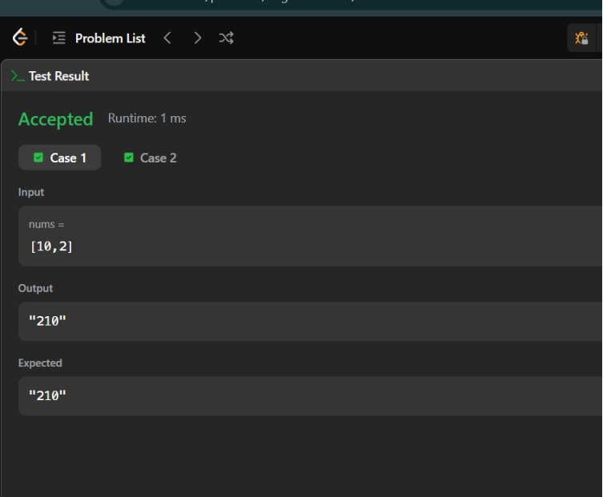

TASK15: Custom Comparators & Sorting Logic
15A: Sort Characters by Frequency
PROGRAM:
import java.util.*;

class Solution {
public String frequencySort(String s) {

HashMap<Character, Integer> map = new HashMap<>();

for (char c : s.toCharArray()) {
map.put(c, map.getOrDefault(c, 0) + 1);
}

List<Character> list = new ArrayList<>(map.keySet());

list.sort((a, b) -> map.get(b) - map.get(a));

StringBuilder result = new StringBuilder();

for (char c : list) {
for (int i = 0; i < map.get(c); i++) {
result.append(c);
}
}

return result.toString();
}
}
OUTPUT:
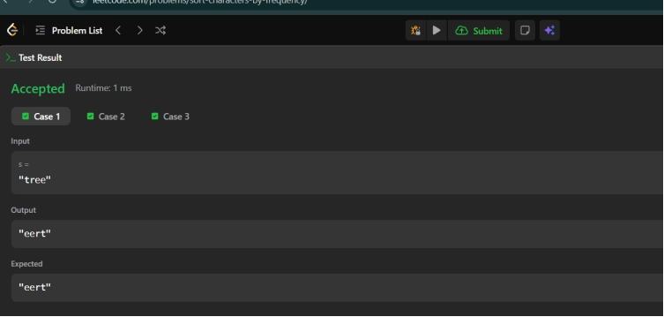
RESULT: Thus the week 3 sessions are completed and executed successfully.

